Assignment 1: Interactive Python

1. In your terminal, type ‘python’. You should see something like this: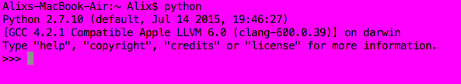

This is the interactive Python shell.

1. Try typing each of the following, pressing ‘enter’ after each:
   1. "Hello World"
   2. 3
   3. 129.401

The shell is echoing your entries back to you!

1. Try typing each of the following, pressing ‘enter’ after each:
   1. 2 + 2
   2. 10 + 3
   3. 6 - 4
   4. 9 - 18
   5. 7 * 8
   6. -4 * 11
   7. 18 / 6
   8. 9 / 4
      1. Did this answer surprise you? Try 9.0 / 4.

The shell does addition, subtraction, multiplication and division… though division with integers (whole numbers) will always return integers.

1. Try typing each of the following, pressing ‘enter’ after each:
   1. print("Hello World")
   2. 4.567 * 8.323 * 17
   3. 3 + 2 * 4
      1. Is Python using the order of operations from math class? Multiplication, division, addition, and subtraction?
   4. _ (you type the underscore by pressing the shift key and holding it while you press the dash key to the right of the 0 key at the top right of the keyboard).
      1. The underscore gets you the most recent output from the shell.
   5. _ + 4
   6. "Hello" + " " + "World"
   7. "la" * 4